***Balancing estuarine and societal health in a changing environment,*** ARC Linkage Project LP150100451

The **aim of this study** is to produce a predictive decision support framework for helping identify land-planning

solutions that best optimise trade-offs between catchment development aspirations (hereafter ‘societal health’) and estuarine ecological integrity and ecosystem service delivery (together, ‘estuarine health’) in the face of a fast growing population and changing climate.

**Chief & Partner Investigators**

* Dr Fiona Valesini - **Murdoch** (CI)
* Assoc. Prof. Matt Hipsey – UWA (CI)
* Prof. Brad Eyre – Sthn Cross Uni. (CI)
* Prof. Paul Plummer – UWA (CI)
* Prof. Mike Elliott – Uni. Hull (PI)
* Dr Kieryn Kilminster – Dept Water (PI)

**Partner Organisations**

* Dept Premier & Cabinet
* Dept Water
* City of Mandurah
* Shire of Murray
* Peel-Harvey Catchment Council
* University of Hull



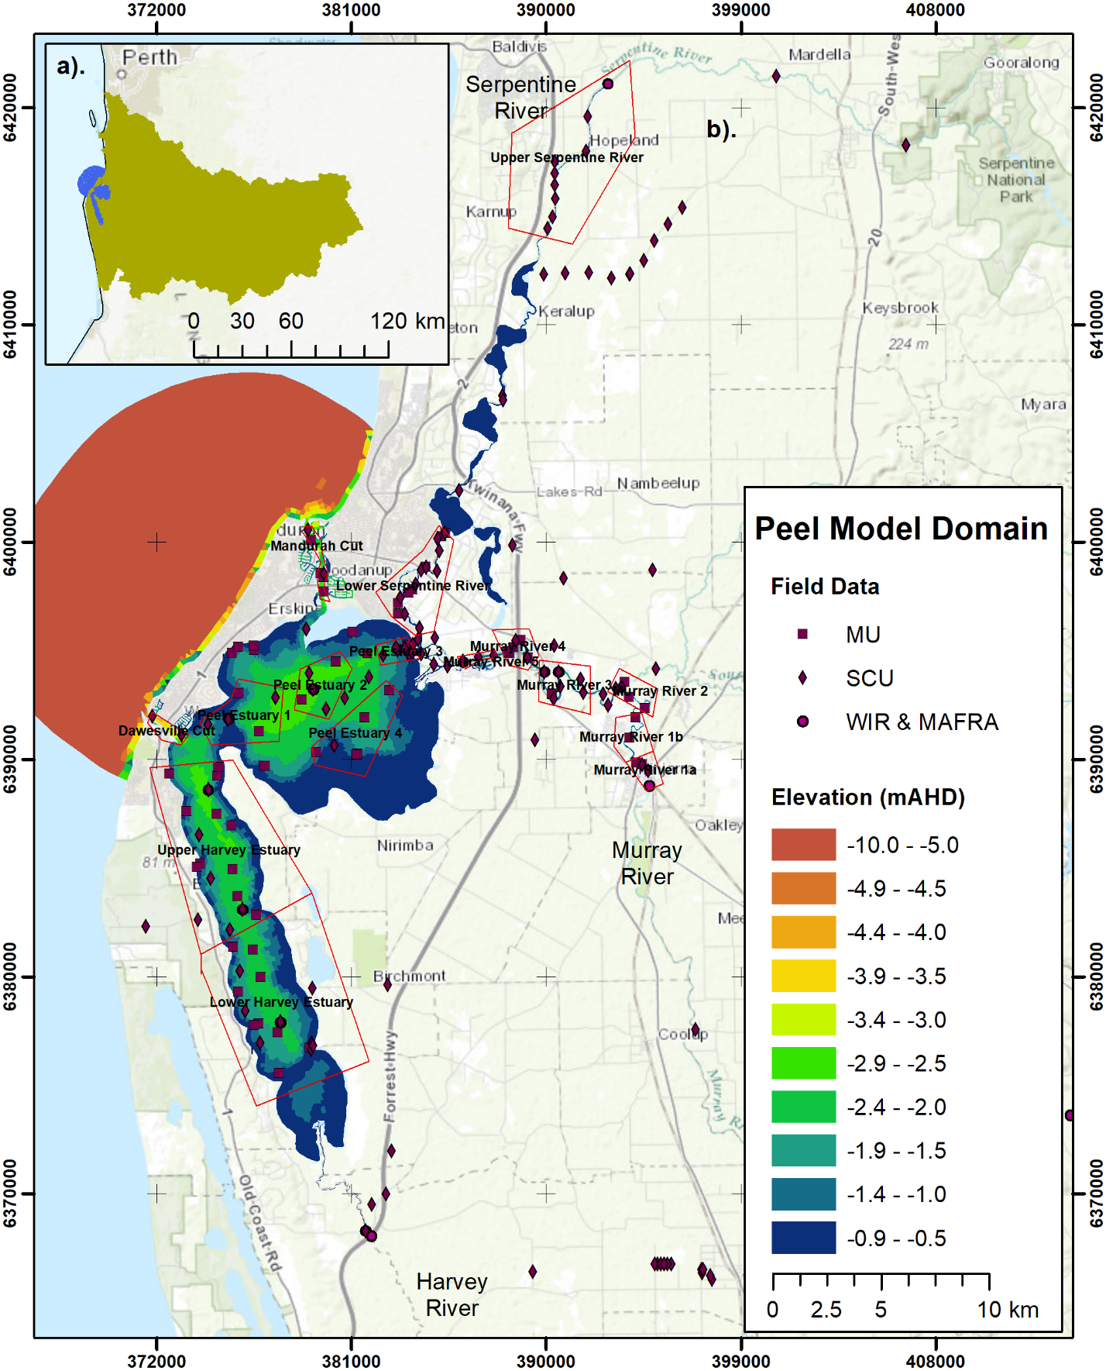



Some Links

<http://peel.science.uwa.edu.au/index.html>

<http://www.murdoch.edu.au/Research-capabilities/Centre-for-Fish-and-Fisheries-Research/>

<http://aed.see.uwa.edu.au/>

<http://scu.edu.au/coastal-biogeochemistry/>

<https://www.tuflow.com/Tuflow%20FV.aspx>

<https://ewater.org.au/products/ewater-source/for-catchments/>

<https://github.com/AquaticEcoDynamics/Peel_ARC>

<http://www.bom.gov.au/>

<https://s3-ap-southeast-2.amazonaws.com/transport.wa/Tide_Packet/TideStations.kml>

<http://wir.water.wa.gov.au/Pages/Water-Information-Reporting.aspx>

Data Section.

Link to the data document being prepared by Fiona.

Table, row per folder with

Name,Agency,Data Type,Collection date range,

Models:

Overview of each of the model types (overview of projects).

Table showing model versions used. Unsure if will get info for Karl’s.

Maybe add the Peishengs hydro models.

